1. What is Entity Framework (EF), and what is it used for?

To simplifies data access. And is Object-relational mapping.

1. In the Movie model, what is the ID field used for?

It is the primary key in the database.

1. In the Movie model, [DataType(DataType.Date)] is a ___________

Propertie. The DataType atribe specifes the type of data.

1. What does Scaffolding a model produce?

It makes the CRUD. The ability to Create, Read, Update, and Delete.

1. What json data name was created in the appsettings.json file for the database connection after scaffolding the Movie model?

After answering this question, do a screen print to verify your answer.

The file is updated with the connection string used to connect a local database.

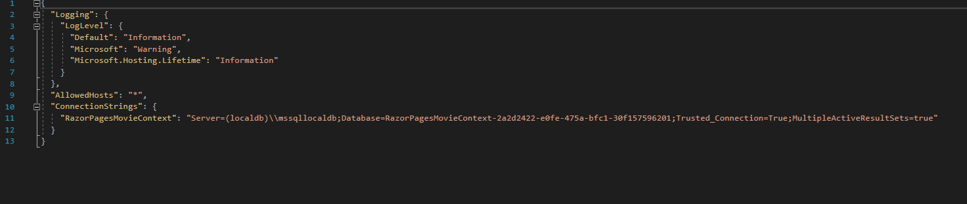

1. What files were produced in the Pages/Movies folder after scaffolding?

Pages/Movies: Create, Delete, Details, Edit, and Index.

1. What other folder/files were created by scaffolding?

Data/RazorPagesMovieContext.cs and Sartup.cs was updated.

1. What tool was used to perform the migration (create/update the database from the Movie model)?

After answering this question, do a screen print to verify your answer.

NuGet Package Manager

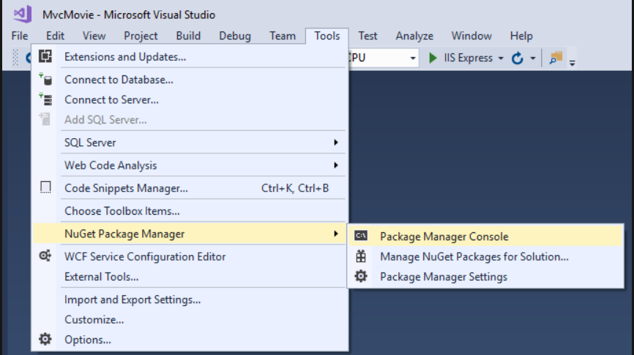

1. Give a brief definition of dependency injection.

These are components that require services like Razor pages are provide these services via construction parameters.

1. According to EF, an entity set is a ________ and an entity is a _______

A entity corresponds to a database and an entity is a row in the table.

1. Run the application, append movies to the url (/movies), and screen print.

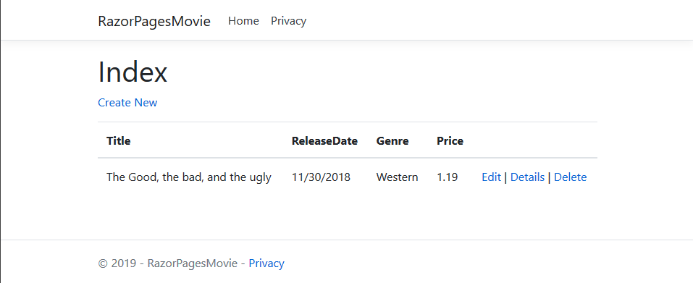

1. Test the Create New feature by entering some data, then screen print. Also experiment with the Details, Edit and Delete options.

